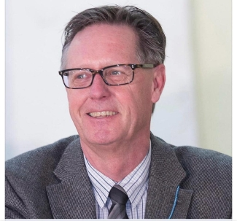

Born in the Netherlands in 1953, Anton Post got his bachelor’s and doctoral degrees from the University of Amsterdam. He then spent a year in Japan as a Brookhaven Institute intern before migrating to Israel for postdoctoral training and later as a biological oceanographer at the Hebrew University. Anton’s research at the Interuniversity Institute for Marine Science in Eilat focused mainly on the nitrogen cycle and the diversity and nutrient physiology of cyanobacteria in the Gulf of Aqaba. To broaden the scope of his research, Anton became a Whitman Center investigator in 2005. In 2008, he joined the University of Chicago, moved to the Marine Biology Laboratory’s Josephine Bay Paul Center in Woods Hole and remained the member of MBL society until 2017. At MBL, Anton’s research concerned how the genomic control of nutrient physiology in cyanobacteria drives algal blooms, and how these blooms shape microbial community structures and affect nutrient cycling. After serving as a program director at the Division of Ocean Sciences for the National Science Foundation for two years while maintaining an active research program at MBL, Anton was recruited by the University of Rhode Island to be director of its new Coastal Resource Center in 2015. Despite his busy schedule, Anton made it all the way to Antarctica for a long research expedition before moving back to Israel in 2018. Since then to the day of his passing, he was the director of the Binational Science Foundation, Israel & USA. Anton was a man of vision, an explorer and a citizen of the world.

